Dr. McLean Test 1 Calculus I February 4, 2009 Name _____________________
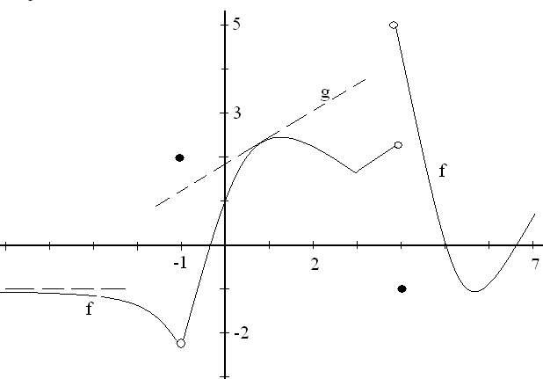
1. The function graphed above, called f, is defined on 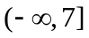 . There is an asymptote at
y = -1 and g is a line tangent to the graph of f at the point (1, 2.3)..
a)What is the first reason that f is not continuous at x = -1?
b) Guess at f ‘(2), the derivative of f when x = 2.
c) What is the range of the function f?

d) Write the equation of the function g.
e) Approximate 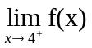.
f) List all values of x for which f is not continuous at x.

g) List all values of x for which f is not differentiable at x.

h) Evaluate 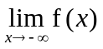.
4. Evaluate 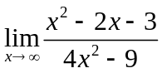
5. Evaluate 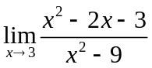.
6. Evaluate 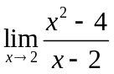.
9. Differentiate each of the following :
- f(x) = 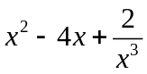
- g(x) = 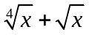.
3- 1 if -2 < x < 0
10. Define m(x) = 1 if x = 0
3 x - 2 if 0 < x < 2
a) Evaluate m’(-1).
b) Evaluate m’(1).
c) State the first reason m is not continuous at x = 0.
d) Evaluate 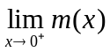
11. Write the equation of the line tangent to the graph of y = 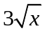 when x = 4.
1. a) 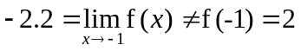 b) – ¾ c) (-2.2, 5) d) (y – 1.8)/(x-0) = 2.8/5
e) 5 f) -1, 4 g) -1, 4, 3 h) limit = -1
4. 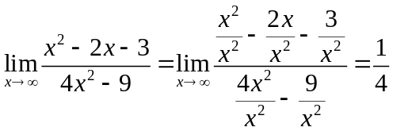
5. 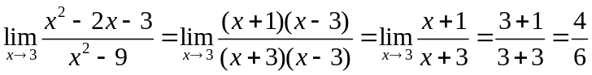
6. 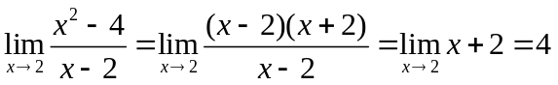
9. a) f (x) = = 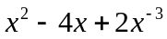 Algebra
f ‘(x) = 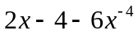 Calculus
b) g(x) = = 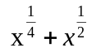 Algebra
g’(x) = 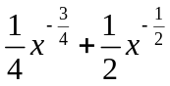
10. a) m’(-1) is the slope over x = -1 which is 6x evaluated at -1 or -6 b) m’(1) is the number in front of the x or 3.c) 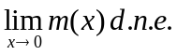 because 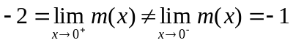.
11. y(4) = 6, y’ = 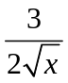 so y’(4) = 1.5/2 = ¾ so (y-6)/(x-4)= ¾ .

